The 1972
“Larrakia Petition”
to Queen Elizabeth II

on display in May 2011
at the National Archives of Australia,
Canberra

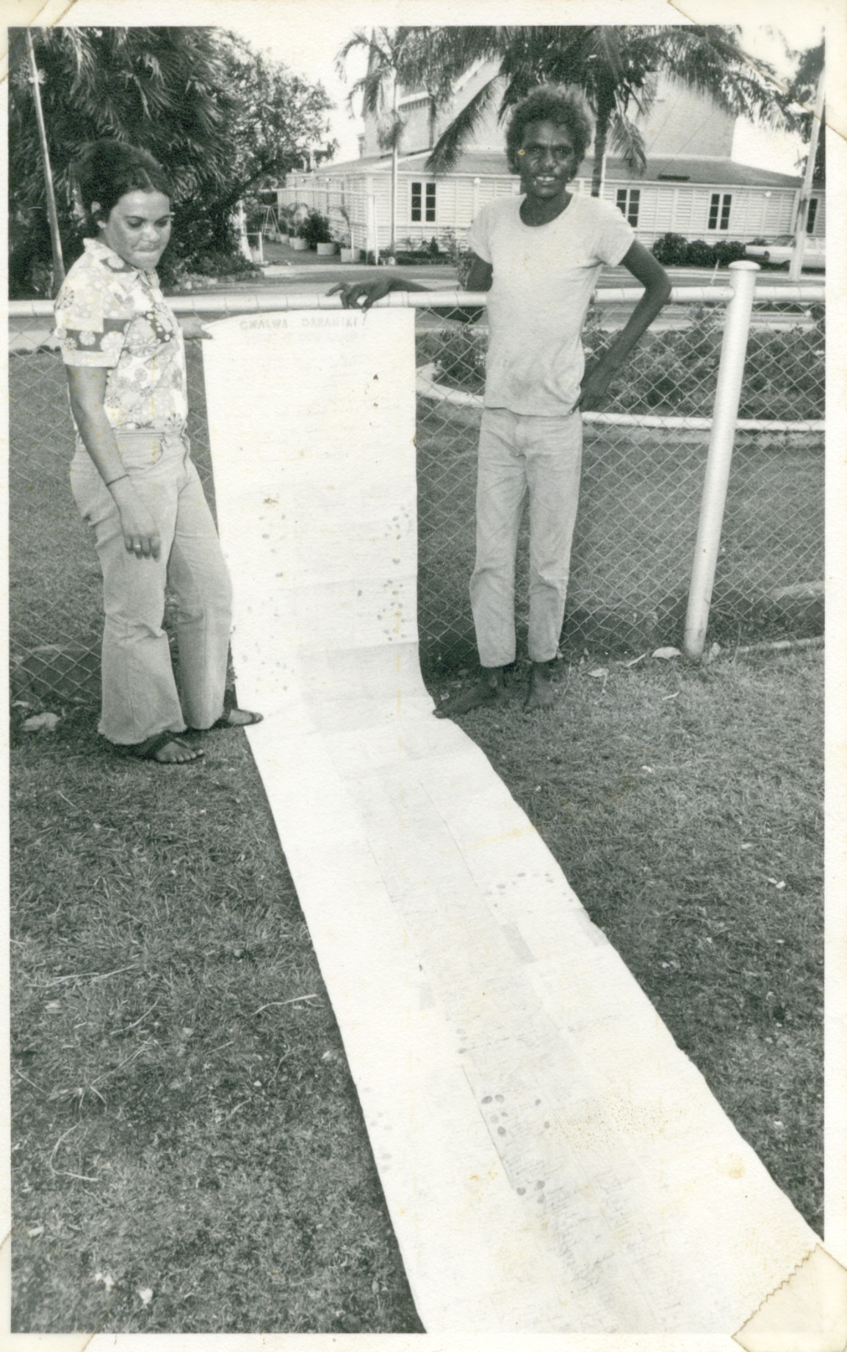
The 1000-signature Aboriginal Petition outside Government House, Darwin, before the visit of Princess Margaret to Darwin on 16th October1972. Eventually the petition was posted to the Queen. Photo:NT News.

